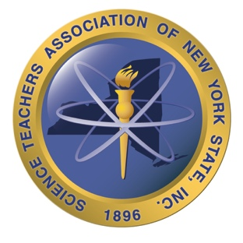
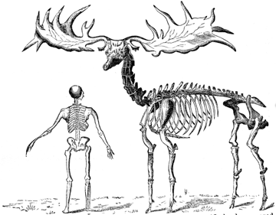
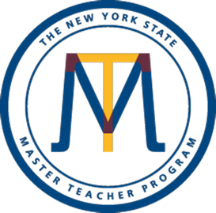

SIX EXTINCTIONS
Announcement: A workshop highlighting the Earth’s Six greatest environmental disasters

Featuring: New York Paleontologists and Biologists presenting up to date information in Earth History, Climate Change and Evolution

When: Saturday, February 10th, 2018 (9:00am – 4:00pm)
Where: Bowers Hall, SUNY Cortland, Cortland, N.Y.
Who: K-12 Teachers of Science or persons interested in Earth History and today’s Biologic Crisis,
(Science background helpful but not necessary)
Cost: $30 (Payable to STANYS)

Supported by: SUNY Cortland departments of Geology, Biology, and The Adolescence Education Science Program, SUNY ESF, SUNY Geneseo, The Paleontological Research Institution and Museum of the Earth, Penn Dixie Fossil Park and Nature Reserve, STANYS Southern Section, and The New York State Master Teacher Program

Hosted by: STANYS Southern Section

You will receive: - Up-to-date information
- Resources and print material
- Invaluable links with NYS scientists
- A commemorative T-shirt
- Coffee and pastries in the morning and delicious buffet lunch
- Certificate of Attendance
**Agenda, maps and other information will follow with confirmation of your registration.

***REGISTER NOW, SPACE IS LIMITED. ***Registration Deadline February 1st

Send your registration to:
Timothy Conner, 251 County Road 9, Chenango Forks, N.Y. 13746
timothy.conner@cortland.edu (607) 648-8850

Registration: Six Extinctions Please enclose $30 check payable to STANYS

Name_____________________________________ Grade level taught_______

Home address ____________________________________________________________________

___________________________________________________________________________________

Home/Cell phone_______________________ T-shirt size: ____________

Email address______________________________________________________________________

